CREATIVE EDUCATIONAL SERVICES
END OF TERM TWO EXAMINATIONS 2024
PRIMARY ONE

LITERACY ONE
Name ________________________________ Stream______
Date _________________________________
Read and follow the following instructions.
- Answer all questions.
- Write well.
- Wrong spellings will lead to loss of marks.

Section A (40 marks)
- Name any one wild animal.
_______________________________________________________
- Why do people wash their hands with soap?
_______________________________________________________
- Draw these human body parts.
eye | leg

- Give any two uses of water to people.
- __________________________________________________
- __________________________________________________
- Give any one way of keeping the toilet clean.
_______________________________________________________
- Which immunisable disease makes children’s legs lame?
_______________________________________________________
- Name this animal.
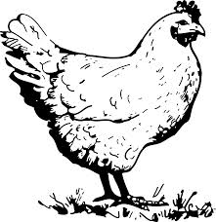

- Why do we keep our school clean?
_______________________________________________________
- (a) Draw a banana fruit.

(b) Give any two reasons why people eat food.
(i) ____________________________________________________
(ii) ____________________________________________________

- How do people control malaria at home?
_______________________________________________________
- Give any one use of each of these animals at home.
- cows ____________________________________________
- dogs ____________________________________________
- Name the sound made by a dog.
_______________________________________________________
- Identify this item used to clean our classrooms.
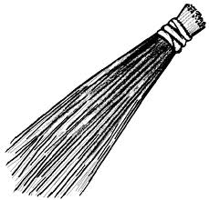

- How do people keep their bodies clean?
_______________________________________________________
- Name the accident shown below.
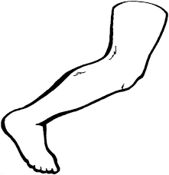

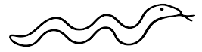

Section B.
- What name is given to the general cleanliness of the body? (personal hygiene, sanitation)
______________________________________________________
- Match animals to their young ones correctly.
animals young ones.
dog kitten
cow cub
cat puppy
lion calf
- dog ____________________________________
- cow ____________________________________
- cat ____________________________________
- lion ____________________________________
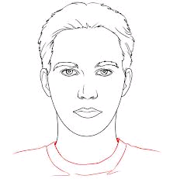
- The diagram below shows a human head. Name the parts marked a and b.

b
c
a

- a _____________________ (ii) b ____________________
(iii) c _______________________________________________
- Where do people put rubbish at school?
_______________________________________________________

- Name any one thing that makes our hands dirty.
_______________________________________________________
- Name the two types of animals.
- ________________________ (b) ______________________
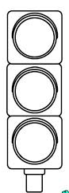
- Write the colours of the traffic lights below.
c
b
a

- _________________________
- _________________________
- _________________________
- Write any one cause of road accidents.
______________________________________________________
- Identify any three items used in keeping personal hygiene.
- _________________________________________________
- _________________________________________________
- _________________________________________________
- Where do fish live?
_______________________________________________________
- Why do people plant trees in their home compounds?
_______________________________________________________

- (a)Give any one place where we can get food.
_______________________________________________________
(b) Mention any one food got from the garden.
_______________________________________________________
- Match A with B correctly.
A B
ears tasting
skin seeing
tongue hearing
eyes feeling
- ears ____________________________________
- skin ____________________________________
- tongue ____________________________________
- eyes ____________________________________
- Name these road signs.
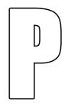 | 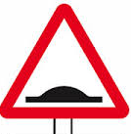

- Give any one danger of poor personal hygiene.
_______________________________________________________
- Draw a house.

End.

